LAPORAN TUGAS
WORKSHOP SISTEM INFROMASI WEB SERVER
(TIF330805)
MINGGU KE-4 Pertemuan 2
SEMESTER III



ACARA 8
PDO, Prepared Statement, Relasi, dan CRUD Lengkap

Disusun Oleh :

Rezza Wahyu Setya Adhy (E41250211)
Golongan A

PROGRAM STUDI DI LUAR KAMPUS UTAMA (PSDKU)
TEKNIK INFORMATIKA KAB. NGANJUK
JURUSAN TEKNOLOGI INFORMASI
POLITEKNIK NEGERI JEMBER
TAHUN 2026
- Studi Kasus
Seorang mahasiswa mengetik di form pencarian: ' OR '1'='1. Jika query digabung langsung dengan string, seluruh data bisa bocor (SQL Injection). Prepared statement memisahkan query dan data, sehingga input berbahaya diperlakukan sebagai data biasa, bukan perintah SQL.
- Tujuan
Mahasiswa menyelesaikan CRUD penuh untuk ketiga resource (Mahasiswa, Prodi, Mata Kuliah) menggunakan PDO prepared statement dan Bootstrap.
- Langkah
- Implementasikan Database class singleton dengan PDO.
- app/Core/Database.php
<?php

namespace App\Core;

use PDO;
use PDOException;

class Database
{
private static ?PDO $instance = null;

public static function getInstance(): PDO
{
if (self::$instance === null) {
$config = require __DIR__ . '/../../config/database.php';

$dsn = "mysql:host={$config['host']};dbname={$config['dbname']};charset={$config['charset']}";

try {
self::$instance = new PDO($dsn, $config['username'], $config['password'], [
PDO::ATTR_ERRMODE => PDO::ERRMODE_EXCEPTION,
PDO::ATTR_DEFAULT_FETCH_MODE => PDO::FETCH_ASSOC,
PDO::ATTR_EMULATE_PREPARES => false,
]);
} catch (PDOException $e) {
die("Koneksi database gagal: " . $e->getMessage());
}
}

return self::$instance;
}
}
- app/Core/Model.php
<?php

namespace App\Core;

use PDO;

class Model
{
protected PDO $db;

public function __construct()
{
$this->db = Database::getInstance();
}
}
- Buat Repository atau method di Model untuk all, find, create, update, delete.
- app/Models/MahasiswaModel.php
<?php

namespace App\Models;

use App\Core\Model;

class MahasiswaModel extends Model
{
public function all(): array
{
$sql = "SELECT m.*, p.nama AS prodi
FROM mahasiswa m
JOIN prodi p ON m.prodi_id = p.id
ORDER BY m.nim";

return $this->db->query($sql)->fetchAll();
}

public function find(int $id): ?array
{
$stmt = $this->db->prepare(
"SELECT m.*, p.nama AS prodi
FROM mahasiswa m
JOIN prodi p ON m.prodi_id = p.id
WHERE m.id = :id"
);
$stmt->execute(['id' => $id]);

$row = $stmt->fetch();
return $row ?: null;
}

public function create(array $d): void
{
$stmt = $this->db->prepare(
"INSERT INTO mahasiswa (nim, nama, email, prodi_id, angkatan, status)
VALUES (:nim, :nama, :email, :prodi_id, :angkatan, :status)"
);
$stmt->execute([
'nim' => $d['nim'],
'nama' => $d['nama'],
'email' => $d['email'],
'prodi_id' => $d['prodi_id'],
'angkatan' => $d['angkatan'],
'status' => $d['status'],
]);
}

public function update(int $id, array $d): void
{
$stmt = $this->db->prepare(
"UPDATE mahasiswa
SET nim = :nim, nama = :nama, email = :email,
prodi_id = :prodi_id, angkatan = :angkatan, status = :status
WHERE id = :id"
);
$stmt->execute([
'nim' => $d['nim'],
'nama' => $d['nama'],
'email' => $d['email'],
'prodi_id' => $d['prodi_id'],
'angkatan' => $d['angkatan'],
'status' => $d['status'],
'id' => $id,
]);
}

public function delete(int $id): void
{
$stmt = $this->db->prepare("DELETE FROM mahasiswa WHERE id = :id");
$stmt->execute(['id' => $id]);
}
}
- app/Models/ProdiModel.php
<?php

namespace App\Models;

use App\Core\Model;

class ProdiModel extends Model
{
public function all(): array
{
return $this->db->query("SELECT * FROM prodi ORDER BY kode")->fetchAll();
}

public function find(int $id): ?array
{
$stmt = $this->db->prepare("SELECT * FROM prodi WHERE id = :id");
$stmt->execute(['id' => $id]);

$row = $stmt->fetch();
return $row ?: null;
}

public function create(array $d): void
{
$stmt = $this->db->prepare("INSERT INTO prodi (kode, nama) VALUES (:kode, :nama)");
$stmt->execute(['kode' => $d['kode'], 'nama' => $d['nama']]);
}

public function update(int $id, array $d): void
{
$stmt = $this->db->prepare("UPDATE prodi SET kode = :kode, nama = :nama WHERE id = :id");
$stmt->execute(['kode' => $d['kode'], 'nama' => $d['nama'], 'id' => $id]);
}

public function delete(int $id): void
{
$stmt = $this->db->prepare("DELETE FROM prodi WHERE id = :id");
$stmt->execute(['id' => $id]);
}
}
- app/Models/MatakuliahModel.php
<?php

namespace App\Models;

use App\Core\Model;

class MatakuliahModel extends Model
{
public function all(): array
{
$sql = "SELECT mk.*, p.nama AS prodi
FROM matakuliah mk
JOIN prodi p ON mk.prodi_id = p.id
ORDER BY mk.kode";

return $this->db->query($sql)->fetchAll();
}

public function find(int $id): ?array
{
$stmt = $this->db->prepare("SELECT * FROM matakuliah WHERE id = :id");
$stmt->execute(['id' => $id]);

$row = $stmt->fetch();
return $row ?: null;
}

public function create(array $d): void
{
$stmt = $this->db->prepare(
"INSERT INTO matakuliah (kode, nama, sks, prodi_id)
VALUES (:kode, :nama, :sks, :prodi_id)"
);
$stmt->execute([
'kode' => $d['kode'],
'nama' => $d['nama'],
'sks' => $d['sks'],
'prodi_id' => $d['prodi_id'],
]);
}

public function update(int $id, array $d): void
{
$stmt = $this->db->prepare(
"UPDATE matakuliah
SET kode = :kode, nama = :nama, sks = :sks, prodi_id = :prodi_id
WHERE id = :id"
);
$stmt->execute([
'kode' => $d['kode'],
'nama' => $d['nama'],
'sks' => $d['sks'],
'prodi_id' => $d['prodi_id'],
'id' => $id,
]);
}

public function delete(int $id): void
{
$stmt = $this->db->prepare("DELETE FROM matakuliah WHERE id = :id");
$stmt->execute(['id' => $id]);
}
}
- Lengkapi Controller + View untuk CRUD Mahasiswa.
- app/Controllers/MahasiswaController.php
<?php

namespace App\Controllers;

use App\Models\MahasiswaModel;
use App\Models\ProdiModel;
use PDOException;

class MahasiswaController
{
public function index(): void
{
$daftarMahasiswa = (new MahasiswaModel())->all();

$content = __DIR__ . '/../Views/mahasiswa/index.php';
require __DIR__ . '/../Views/layouts/main.php';
}

public function create(): void
{
$mhs = null; // null = form tambah (tidak ada data lama)
$prodiList = (new ProdiModel())->all();

$content = __DIR__ . '/../Views/mahasiswa/form.php';
require __DIR__ . '/../Views/layouts/main.php';
}

public function store(): void
{
$data = $this->input();

if ($data['nim'] === '' || $data['nama'] === '' || $data['prodi_id'] < 1) {
$_SESSION['flash'] = ['type' => 'danger', 'message' => 'NIM, nama, dan prodi wajib diisi'];
header('Location: /acara8/si-akademik/public/mahasiswa/create');
exit;
}

try {
(new MahasiswaModel())->create($data);
} catch (PDOException $e) {
$_SESSION['flash'] = ['type' => 'danger', 'message' => 'Gagal menyimpan: NIM sudah terdaftar'];
header('Location: /acara8/si-akademik/public/mahasiswa/create');
exit;
}

$_SESSION['flash'] = ['type' => 'success', 'message' => 'Mahasiswa berhasil ditambahkan'];
header('Location: /acara8/si-akademik/public/mahasiswa');
exit;
}

public function show(int $id): void
{
$mhs = (new MahasiswaModel())->find($id);

if ($mhs === null) {
http_response_code(404);
echo "404 - Mahasiswa dengan ID {$id} tidak ditemukan";
return;
}

echo "<h1>Detail Mahasiswa (ID: {$id})</h1>";
echo "<p>" . htmlspecialchars("{$mhs['nim']} - {$mhs['nama']} ({$mhs['prodi']})") . "</p>";
echo "<p>Email: " . htmlspecialchars($mhs['email']) . "</p>";
echo "<p>Angkatan: " . htmlspecialchars($mhs['angkatan']) . "</p>";
echo "<a href='/acara8/si-akademik/public/mahasiswa'>Kembali</a>";
}

public function edit(int $id): void
{
$mhs = (new MahasiswaModel())->find($id); // berisi data lama = form edit

if ($mhs === null) {
http_response_code(404);
echo "404 - Mahasiswa dengan ID {$id} tidak ditemukan";
return;
}

$prodiList = (new ProdiModel())->all();

$content = __DIR__ . '/../Views/mahasiswa/form.php';
require __DIR__ . '/../Views/layouts/main.php';
}

public function update(int $id): void
{
$data = $this->input();

if ($data['nim'] === '' || $data['nama'] === '' || $data['prodi_id'] < 1) {
$_SESSION['flash'] = ['type' => 'danger', 'message' => 'NIM, nama, dan prodi wajib diisi'];
header("Location: /acara8/si-akademik/public/mahasiswa/{$id}/edit");
exit;
}

try {
(new MahasiswaModel())->update($id, $data);
} catch (PDOException $e) {
$_SESSION['flash'] = ['type' => 'danger', 'message' => 'Gagal mengubah: NIM sudah dipakai'];
header("Location: /acara8/si-akademik/public/mahasiswa/{$id}/edit");
exit;
}

$_SESSION['flash'] = ['type' => 'success', 'message' => 'Data mahasiswa berhasil diubah'];
header('Location: /acara8/si-akademik/public/mahasiswa');
exit;
}

public function destroy(int $id): void
{
(new MahasiswaModel())->delete($id);

$_SESSION['flash'] = ['type' => 'success', 'message' => 'Data mahasiswa berhasil dihapus'];
header('Location: /acara8/si-akademik/public/mahasiswa');
exit;
}

// Mengambil dan membersihkan input form
private function input(): array
{
$status = $_POST['status'] ?? 'aktif';

return [
'nim' => trim($_POST['nim'] ?? ''),
'nama' => trim($_POST['nama'] ?? ''),
'email' => trim($_POST['email'] ?? ''),
'prodi_id' => (int) ($_POST['prodi_id'] ?? 0),
'angkatan' => (int) ($_POST['angkatan'] ?? date('Y')),
'status' => in_array($status, ['aktif', 'cuti', 'lulus'], true) ? $status : 'aktif',
];
}
}
- app/Views/mahasiswa/index.php
<div class="d-flex justify-content-between align-items-center mb-3">
<h5 class="m-0">Daftar Mahasiswa</h5>
<a href="/acara8/si-akademik/public/mahasiswa/create" class="btn btn-primary btn-sm">+ Tambah Mahasiswa</a>
</div>

<table class="table table-bordered table-striped align-middle">
<thead class="table-dark">
<tr>
<th>No</th>
<th>NIM</th>
<th>Nama</th>
<th>Email</th>
<th>Program Studi</th>
<th>Angkatan</th>
<th>Status</th>
<th>Aksi</th>
</tr>
</thead>
<tbody>
<?php if (empty($daftarMahasiswa)): ?>
<tr><td colspan="8" class="text-center text-muted">Belum ada data</td></tr>
<?php endif; ?>

<?php foreach ($daftarMahasiswa as $i => $mhs): ?>
<tr>
<td><?= $i + 1 ?></td>
<td><?= htmlspecialchars($mhs['nim']) ?></td>
<td><?= htmlspecialchars($mhs['nama']) ?></td>
<td><?= htmlspecialchars($mhs['email']) ?></td>
<td><?= htmlspecialchars($mhs['prodi']) ?></td>
<td><?= htmlspecialchars($mhs['angkatan']) ?></td>
<?php $warna = ['aktif' => 'success', 'cuti' => 'warning', 'lulus' => 'primary'][$mhs['status']] ?? 'secondary'; ?>
<td><span class="badge bg-<?= $warna ?>"><?= htmlspecialchars($mhs['status']) ?></span></td>
<td>
<a href="/acara8/si-akademik/public/mahasiswa/<?= $mhs['id'] ?>" class="btn btn-sm btn-info">Detail</a>
<a href="/acara8/si-akademik/public/mahasiswa/<?= $mhs['id'] ?>/edit" class="btn btn-sm btn-warning">Edit</a>
<form action="/acara8/si-akademik/public/mahasiswa/<?= $mhs['id'] ?>/delete" method="POST" class="d-inline"
onsubmit="return confirm('Yakin ingin menghapus data ini?')">
<button type="submit" class="btn btn-sm btn-danger">Hapus</button>
</form>
</td>
</tr>
<?php endforeach; ?>
</tbody>
</table>
- app/Views/mahasiswa/form.php
<?php
$isEdit = $mhs !== null;
$action = $isEdit
? "/acara8/si-akademik/public/mahasiswa/{$mhs['id']}/update"
: "/acara8/si-akademik/public/mahasiswa";
?>
<h5 class="mb-3"><?= $isEdit ? 'Edit' : 'Tambah' ?> Mahasiswa</h5>

<form action="<?= $action ?>" method="POST">
<div class="mb-3">
<label class="form-label">NIM</label>
<input type="text" name="nim" class="form-control" value="<?= htmlspecialchars($mhs['nim'] ?? '') ?>" required>
</div>
<div class="mb-3">
<label class="form-label">Nama</label>
<input type="text" name="nama" class="form-control" value="<?= htmlspecialchars($mhs['nama'] ?? '') ?>" required>
</div>
<div class="mb-3">
<label class="form-label">Email</label>
<input type="email" name="email" class="form-control" value="<?= htmlspecialchars($mhs['email'] ?? '') ?>" required>
</div>
<div class="mb-3">
<label class="form-label">Program Studi</label>
<select name="prodi_id" class="form-select" required>
<option value="">-- Pilih Program Studi --</option>
<?php foreach ($prodiList as $p): ?>
<option value="<?= $p['id'] ?>" <?= ($mhs['prodi_id'] ?? '') == $p['id'] ? 'selected' : '' ?>>
<?= htmlspecialchars($p['nama']) ?>
</option>
<?php endforeach; ?>
</select>
</div>
<div class="mb-3">
<label class="form-label">Angkatan</label>
<input type="number" name="angkatan" class="form-control" value="<?= htmlspecialchars($mhs['angkatan'] ?? date('Y')) ?>" required>
</div>
<div class="mb-3">
<label class="form-label">Status</label>
<select name="status" class="form-select">
<?php foreach (['aktif', 'cuti', 'lulus'] as $s): ?>
<option value="<?= $s ?>" <?= ($mhs['status'] ?? 'aktif') === $s ? 'selected' : '' ?>><?= ucfirst($s) ?></option>
<?php endforeach; ?>
</select>
</div>
<button type="submit" class="btn btn-primary">Simpan</button>
<a href="/acara8/si-akademik/public/mahasiswa" class="btn btn-secondary">Batal</a>
</form>
- routes/web.php
<?php

use App\Core\Middleware\AuthMiddleware;

$auth = [AuthMiddleware::class];

$routes = [
'GET' => [
'/' => ['HomeController', 'index'],
'/login' => ['AuthController', 'loginForm'],
'/logout' => ['AuthController', 'logout'],
'/dashboard' => ['DashboardController', 'index', 'middleware' => $auth],

'/mahasiswa' => ['MahasiswaController', 'index', 'middleware' => $auth],
'/mahasiswa/create' => ['MahasiswaController', 'create', 'middleware' => $auth],
'/mahasiswa/{id}' => ['MahasiswaController', 'show', 'middleware' => $auth],
'/mahasiswa/{id}/edit' => ['MahasiswaController', 'edit', 'middleware' => $auth],

'/prodi' => ['ProdiController', 'index', 'middleware' => $auth],
'/prodi/create' => ['ProdiController', 'create', 'middleware' => $auth],
'/prodi/{id}/edit' => ['ProdiController', 'edit', 'middleware' => $auth],

'/matakuliah' => ['MatakuliahController', 'index', 'middleware' => $auth],
'/matakuliah/create' => ['MatakuliahController', 'create', 'middleware' => $auth],
'/matakuliah/{id}/edit' => ['MatakuliahController', 'edit', 'middleware' => $auth],
],
'POST' => [
'/login' => ['AuthController', 'login'],

'/mahasiswa' => ['MahasiswaController', 'store', 'middleware' => $auth],
'/mahasiswa/{id}/update' => ['MahasiswaController', 'update', 'middleware' => $auth],
'/mahasiswa/{id}/delete' => ['MahasiswaController', 'destroy', 'middleware' => $auth],

'/prodi' => ['ProdiController', 'store', 'middleware' => $auth],
'/prodi/{id}/update' => ['ProdiController', 'update', 'middleware' => $auth],
'/prodi/{id}/delete' => ['ProdiController', 'destroy', 'middleware' => $auth],

'/matakuliah' => ['MatakuliahController', 'store', 'middleware' => $auth],
'/matakuliah/{id}/update' => ['MatakuliahController', 'update', 'middleware' => $auth],
'/matakuliah/{id}/delete' => ['MatakuliahController', 'destroy', 'middleware' => $auth],
],
];
- public/index.php
<?php
session_start(); // harus dipanggil sebelum ada output

require_once __DIR__ . '/../app/Core/Database.php';
require_once __DIR__ . '/../app/Core/Model.php';
require_once __DIR__ . '/../app/Core/Middleware/AuthMiddleware.php';
require_once __DIR__ . '/../app/Models/MahasiswaModel.php';
require_once __DIR__ . '/../app/Models/ProdiModel.php';
require_once __DIR__ . '/../app/Models/MatakuliahModel.php';
require_once __DIR__ . '/../app/Controllers/HomeController.php';
require_once __DIR__ . '/../app/Controllers/AuthController.php';
require_once __DIR__ . '/../app/Controllers/DashboardController.php';
require_once __DIR__ . '/../app/Controllers/MahasiswaController.php';
require_once __DIR__ . '/../app/Controllers/ProdiController.php';
require_once __DIR__ . '/../app/Controllers/MatakuliahController.php';
require_once __DIR__ . '/../routes/web.php';

$uri = parse_url($_SERVER['REQUEST_URI'], PHP_URL_PATH);

$base = '/acara8/si-akademik/public';
if (str_starts_with($uri, $base)) {
$uri = substr($uri, strlen($base)) ?: '/';
}

$method = $_SERVER['REQUEST_METHOD'];

// 1. Cari route yang cocok persis
$route = $routes[$method][$uri] ?? null;
$params = [];

// 2. Kalau tidak ada, cari route berparameter, misal /mahasiswa/5/edit
if ($route === null) {
foreach ($routes[$method] ?? [] as $pattern => $r) {
if (!str_contains($pattern, '{')) {
continue;
}
$regex = '#^' . preg_replace('#\{\w+\}#', '(\d+)', $pattern) . '$#';
if (preg_match($regex, $uri, $cocok)) {
array_shift($cocok);
$route = $r;
$params = array_map('intval', $cocok);
break;
}
}
}

// 3. Tidak ketemu -> 404
if ($route === null) {
http_response_code(404);
echo "404 - Halaman tidak ditemukan";
exit;
}

// 4. Jalankan middleware (jika ada)
foreach ($route['middleware'] ?? [] as $mw) {
$mwInstance = new $mw();
$mwInstance->handle();
}

// 5. Panggil controller
$controllerClass = "App\\Controllers\\{$route[0]}";
$controller = new $controllerClass();
$controller->{$route[1]}(...$params);

- Output
- /mahasiswa
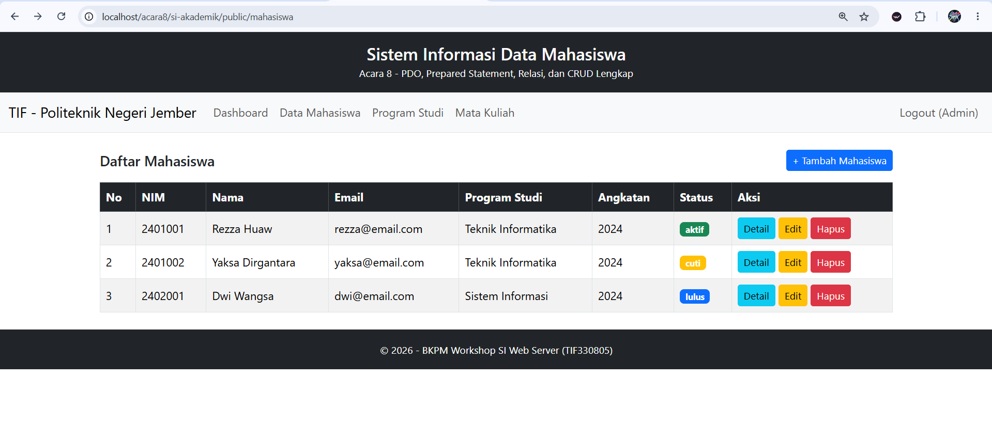
- /mahasiswa/create
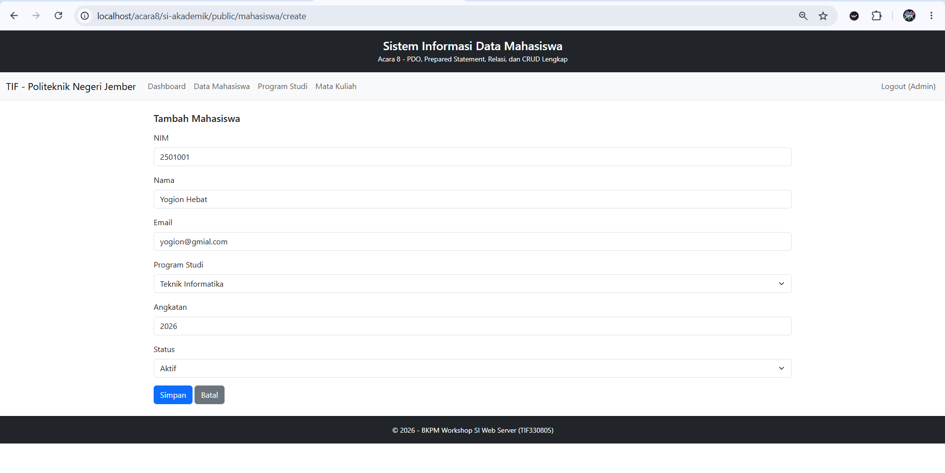
- /mahasiswa berhasil di tambah
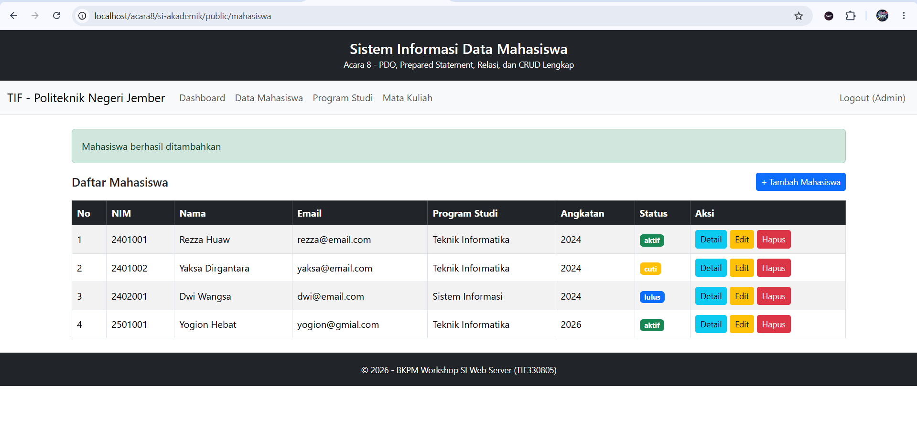

- /mahasiswa/4/edit
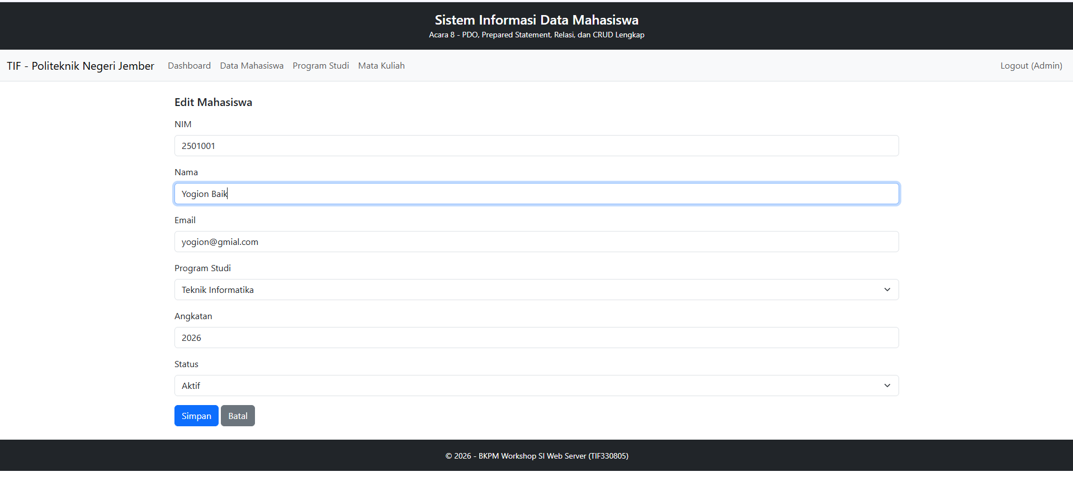
- /mahasiswa berhasil di edit
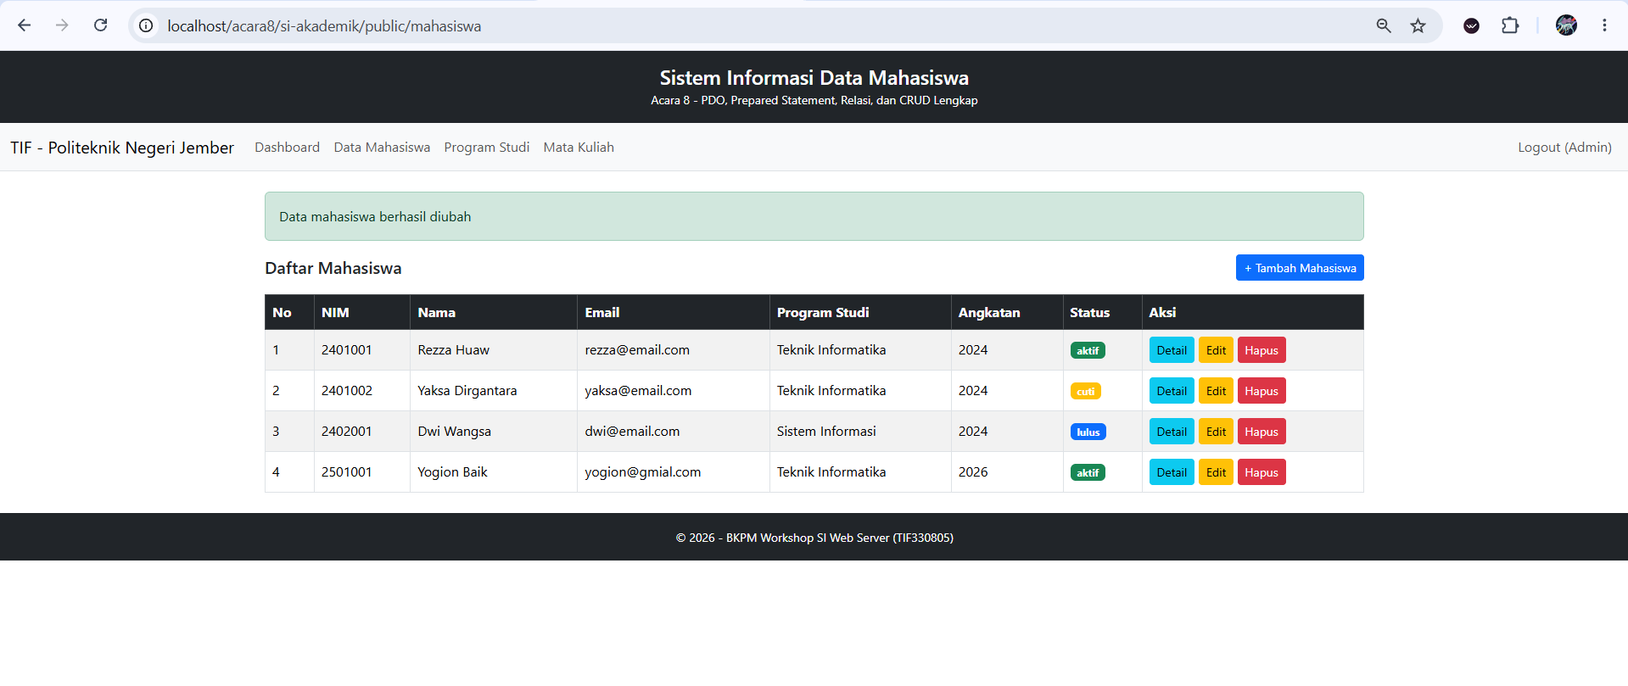
- /mahasiswa hapus
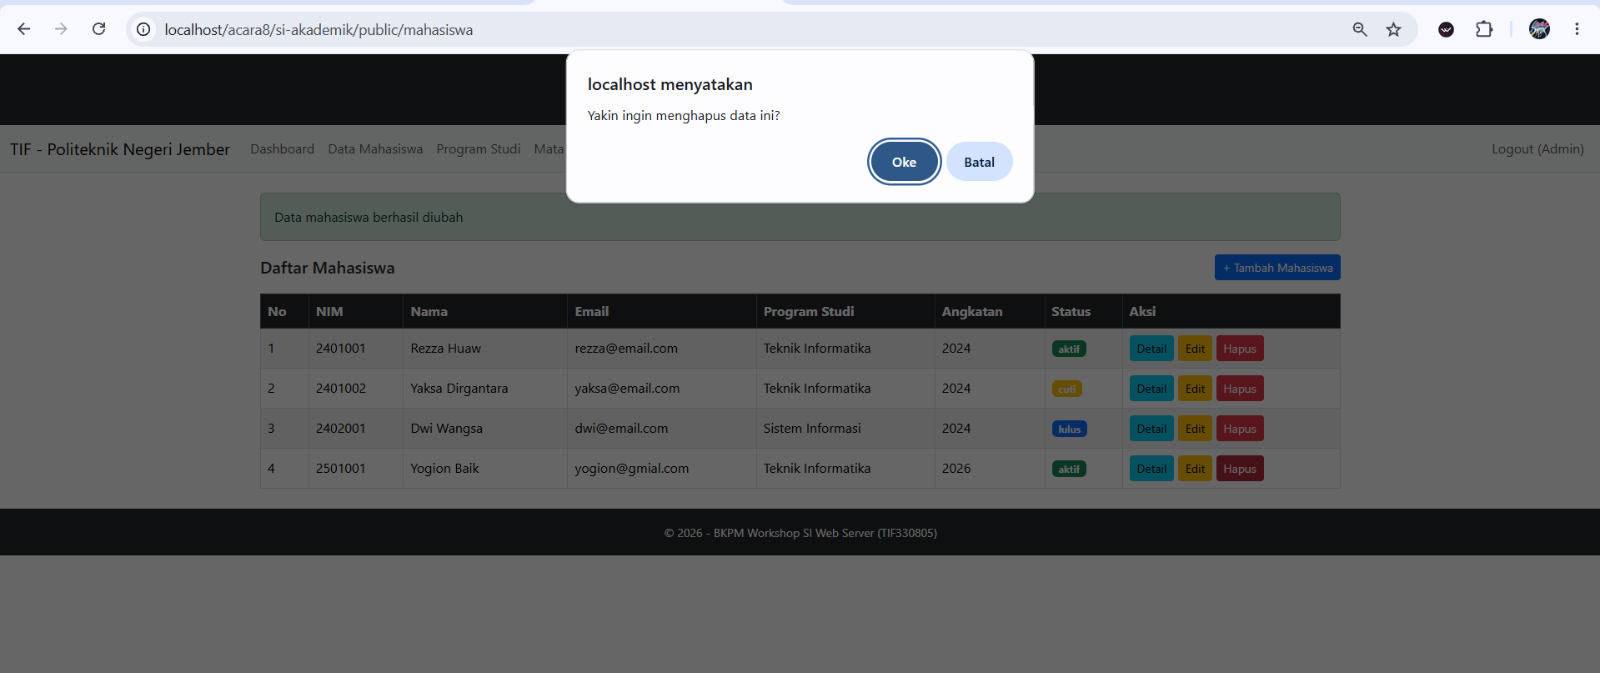

- Ulangi untuk Prodi dan Mata Kuliah.
- app/Controllers/ProdiController.php
<?php

namespace App\Controllers;

use App\Models\ProdiModel;
use PDOException;

class ProdiController
{
public function index(): void
{
$daftarProdi = (new ProdiModel())->all();

$content = __DIR__ . '/../Views/prodi/index.php';
require __DIR__ . '/../Views/layouts/main.php';
}

public function create(): void
{
$prodi = null; // null = form tambah

$content = __DIR__ . '/../Views/prodi/form.php';
require __DIR__ . '/../Views/layouts/main.php';
}

public function store(): void
{
$data = $this->input();

if ($data['kode'] === '' || $data['nama'] === '') {
$_SESSION['flash'] = ['type' => 'danger', 'message' => 'Kode dan nama prodi wajib diisi'];
header('Location: /acara8/si-akademik/public/prodi/create');
exit;
}

try {
(new ProdiModel())->create($data);
} catch (PDOException $e) {
$_SESSION['flash'] = ['type' => 'danger', 'message' => 'Gagal menyimpan: kode prodi sudah dipakai'];
header('Location: /acara8/si-akademik/public/prodi/create');
exit;
}

$_SESSION['flash'] = ['type' => 'success', 'message' => 'Prodi berhasil ditambahkan'];
header('Location: /acara8/si-akademik/public/prodi');
exit;
}

public function edit(int $id): void
{
$prodi = (new ProdiModel())->find($id);

if ($prodi === null) {
http_response_code(404);
echo "404 - Prodi dengan ID {$id} tidak ditemukan";
return;
}

$content = __DIR__ . '/../Views/prodi/form.php';
require __DIR__ . '/../Views/layouts/main.php';
}

public function update(int $id): void
{
$data = $this->input();

if ($data['kode'] === '' || $data['nama'] === '') {
$_SESSION['flash'] = ['type' => 'danger', 'message' => 'Kode dan nama prodi wajib diisi'];
header("Location: /acara8/si-akademik/public/prodi/{$id}/edit");
exit;
}

try {
(new ProdiModel())->update($id, $data);
} catch (PDOException $e) {
$_SESSION['flash'] = ['type' => 'danger', 'message' => 'Gagal mengubah: kode prodi sudah dipakai'];
header("Location: /acara8/si-akademik/public/prodi/{$id}/edit");
exit;
}

$_SESSION['flash'] = ['type' => 'success', 'message' => 'Prodi berhasil diubah'];
header('Location: /acara8/si-akademik/public/prodi');
exit;
}

public function destroy(int $id): void
{
try {
(new ProdiModel())->delete($id);
$_SESSION['flash'] = ['type' => 'success', 'message' => 'Prodi berhasil dihapus'];
} catch (PDOException $e) {
// Foreign key RESTRICT: prodi masih dipakai mahasiswa / mata kuliah
$_SESSION['flash'] = ['type' => 'danger', 'message' => 'Prodi tidak dapat dihapus karena masih dipakai'];
}

header('Location: /acara8/si-akademik/public/prodi');
exit;
}

private function input(): array
{
return [
'kode' => trim($_POST['kode'] ?? ''),
'nama' => trim($_POST['nama'] ?? ''),
];
}
}
- app/Views/prodi/index.php
<div class="d-flex justify-content-between align-items-center mb-3">
<h5 class="m-0">Daftar Program Studi</h5>
<a href="/acara8/si-akademik/public/prodi/create" class="btn btn-primary btn-sm">+ Tambah Prodi</a>
</div>

<table class="table table-bordered table-striped align-middle">
<thead class="table-dark">
<tr>
<th>No</th>
<th>Kode</th>
<th>Nama Program Studi</th>
<th>Aksi</th>
</tr>
</thead>
<tbody>
<?php if (empty($daftarProdi)): ?>
<tr><td colspan="4" class="text-center text-muted">Belum ada data</td></tr>
<?php endif; ?>

<?php foreach ($daftarProdi as $i => $p): ?>
<tr>
<td><?= $i + 1 ?></td>
<td><?= htmlspecialchars($p['kode']) ?></td>
<td><?= htmlspecialchars($p['nama']) ?></td>
<td>
<a href="/acara8/si-akademik/public/prodi/<?= $p['id'] ?>/edit" class="btn btn-sm btn-warning">Edit</a>
<form action="/acara8/si-akademik/public/prodi/<?= $p['id'] ?>/delete" method="POST" class="d-inline"
onsubmit="return confirm('Yakin ingin menghapus data ini?')">
<button type="submit" class="btn btn-sm btn-danger">Hapus</button>
</form>
</td>
</tr>
<?php endforeach; ?>
</tbody>
</table>
- app/Views/prodi/form.php
<?php
$isEdit = $prodi !== null;
$action = $isEdit
? "/acara8/si-akademik/public/prodi/{$prodi['id']}/update"
: "/acara8/si-akademik/public/prodi";
?>
<h5 class="mb-3"><?= $isEdit ? 'Edit' : 'Tambah' ?> Program Studi</h5>

<form action="<?= $action ?>" method="POST">
<div class="mb-3">
<label class="form-label">Kode</label>
<input type="text" name="kode" class="form-control" maxlength="10" value="<?= htmlspecialchars($prodi['kode'] ?? '') ?>" required>
</div>
<div class="mb-3">
<label class="form-label">Nama Program Studi</label>
<input type="text" name="nama" class="form-control" value="<?= htmlspecialchars($prodi['nama'] ?? '') ?>" required>
</div>
<button type="submit" class="btn btn-primary">Simpan</button>
<a href="/acara8/si-akademik/public/prodi" class="btn btn-secondary">Batal</a>
</form>

- app/Controllers/MatakuliahController.php
<?php

namespace App\Controllers;

use App\Models\MatakuliahModel;
use App\Models\ProdiModel;
use PDOException;

class MatakuliahController
{
public function index(): void
{
$daftarMatakuliah = (new MatakuliahModel())->all();

$content = __DIR__ . '/../Views/matakuliah/index.php';
require __DIR__ . '/../Views/layouts/main.php';
}

public function create(): void
{
$mk = null; // null = form tambah
$prodiList = (new ProdiModel())->all();

$content = __DIR__ . '/../Views/matakuliah/form.php';
require __DIR__ . '/../Views/layouts/main.php';
}

public function store(): void
{
$data = $this->input();

if ($data['kode'] === '' || $data['nama'] === '' || $data['sks'] < 1 || $data['prodi_id'] < 1) {
$_SESSION['flash'] = ['type' => 'danger', 'message' => 'Semua kolom wajib diisi dengan benar'];
header('Location: /acara8/si-akademik/public/matakuliah/create');
exit;
}

try {
(new MatakuliahModel())->create($data);
} catch (PDOException $e) {
$_SESSION['flash'] = ['type' => 'danger', 'message' => 'Gagal menyimpan: kode mata kuliah sudah dipakai'];
header('Location: /acara8/si-akademik/public/matakuliah/create');
exit;
}

$_SESSION['flash'] = ['type' => 'success', 'message' => 'Mata kuliah berhasil ditambahkan'];
header('Location: /acara8/si-akademik/public/matakuliah');
exit;
}

public function edit(int $id): void
{
$mk = (new MatakuliahModel())->find($id);

if ($mk === null) {
http_response_code(404);
echo "404 - Mata kuliah dengan ID {$id} tidak ditemukan";
return;
}

$prodiList = (new ProdiModel())->all();

$content = __DIR__ . '/../Views/matakuliah/form.php';
require __DIR__ . '/../Views/layouts/main.php';
}

public function update(int $id): void
{
$data = $this->input();

if ($data['kode'] === '' || $data['nama'] === '' || $data['sks'] < 1 || $data['prodi_id'] < 1) {
$_SESSION['flash'] = ['type' => 'danger', 'message' => 'Semua kolom wajib diisi dengan benar'];
header("Location: /acara8/si-akademik/public/matakuliah/{$id}/edit");
exit;
}

try {
(new MatakuliahModel())->update($id, $data);
} catch (PDOException $e) {
$_SESSION['flash'] = ['type' => 'danger', 'message' => 'Gagal mengubah: kode mata kuliah sudah dipakai'];
header("Location: /acara8/si-akademik/public/matakuliah/{$id}/edit");
exit;
}

$_SESSION['flash'] = ['type' => 'success', 'message' => 'Mata kuliah berhasil diubah'];
header('Location: /acara8/si-akademik/public/matakuliah');
exit;
}

public function destroy(int $id): void
{
(new MatakuliahModel())->delete($id);

$_SESSION['flash'] = ['type' => 'success', 'message' => 'Mata kuliah berhasil dihapus'];
header('Location: /acara8/si-akademik/public/matakuliah');
exit;
}

private function input(): array
{
return [
'kode' => trim($_POST['kode'] ?? ''),
'nama' => trim($_POST['nama'] ?? ''),
'sks' => (int) ($_POST['sks'] ?? 0),
'prodi_id' => (int) ($_POST['prodi_id'] ?? 0),
];
}
}
- app/Views/matakuliah/index.php
<div class="d-flex justify-content-between align-items-center mb-3">
<h5 class="m-0">Daftar Mata Kuliah</h5>
<a href="/acara8/si-akademik/public/matakuliah/create" class="btn btn-primary btn-sm">+ Tambah Mata Kuliah</a>
</div>

<table class="table table-bordered table-striped align-middle">
<thead class="table-dark">
<tr>
<th>No</th>
<th>Kode</th>
<th>Nama Mata Kuliah</th>
<th>SKS</th>
<th>Program Studi</th>
<th>Aksi</th>
</tr>
</thead>
<tbody>
<?php if (empty($daftarMatakuliah)): ?>
<tr><td colspan="6" class="text-center text-muted">Belum ada data</td></tr>
<?php endif; ?>

<?php foreach ($daftarMatakuliah as $i => $m): ?>
<tr>
<td><?= $i + 1 ?></td>
<td><?= htmlspecialchars($m['kode']) ?></td>
<td><?= htmlspecialchars($m['nama']) ?></td>
<td><?= htmlspecialchars($m['sks']) ?></td>
<td><?= htmlspecialchars($m['prodi']) ?></td>
<td>
<a href="/acara8/si-akademik/public/matakuliah/<?= $m['id'] ?>/edit" class="btn btn-sm btn-warning">Edit</a>
<form action="/acara8/si-akademik/public/matakuliah/<?= $m['id'] ?>/delete" method="POST" class="d-inline"
onsubmit="return confirm('Yakin ingin menghapus data ini?')">
<button type="submit" class="btn btn-sm btn-danger">Hapus</button>
</form>
</td>
</tr>
<?php endforeach; ?>
</tbody>
</table>
- app/Views/mataakuliah/form.php
<?php
$isEdit = $mk !== null;
$action = $isEdit
? "/acara8/si-akademik/public/matakuliah/{$mk['id']}/update"
: "/acara8/si-akademik/public/matakuliah";
?>
<h5 class="mb-3"><?= $isEdit ? 'Edit' : 'Tambah' ?> Mata Kuliah</h5>

<form action="<?= $action ?>" method="POST">
<div class="mb-3">
<label class="form-label">Kode</label>
<input type="text" name="kode" class="form-control" maxlength="10" value="<?= htmlspecialchars($mk['kode'] ?? '') ?>" required>
</div>
<div class="mb-3">
<label class="form-label">Nama Mata Kuliah</label>
<input type="text" name="nama" class="form-control" value="<?= htmlspecialchars($mk['nama'] ?? '') ?>" required>
</div>
<div class="mb-3">
<label class="form-label">SKS</label>
<input type="number" name="sks" class="form-control" min="1" max="6" value="<?= htmlspecialchars($mk['sks'] ?? '') ?>" required>
</div>
<div class="mb-3">
<label class="form-label">Program Studi</label>
<select name="prodi_id" class="form-select" required>
<option value="">-- Pilih Program Studi --</option>
<?php foreach ($prodiList as $p): ?>
<option value="<?= $p['id'] ?>" <?= ($mk['prodi_id'] ?? '') == $p['id'] ? 'selected' : '' ?>>
<?= htmlspecialchars($p['nama']) ?>
</option>
<?php endforeach; ?>
</select>
</div>
<button type="submit" class="btn btn-primary">Simpan</button>
<a href="/acara8/si-akademik/public/matakuliah" class="btn btn-secondary">Batal</a>
</form>
- app/Views/partials/navbar.php
<nav class="navbar navbar-expand-lg navbar-light bg-light border-bottom">
<div class="container-fluid">
<a class="navbar-brand" href="/acara8/si-akademik/public/">TIF - Politeknik Negeri Jember</a>
<div class="collapse navbar-collapse">
<ul class="navbar-nav me-auto">
<?php if (!empty($_SESSION['logged_in'])): ?>
<li class="nav-item">
<a class="nav-link" href="/acara8/si-akademik/public/dashboard">Dashboard</a>
</li>
<li class="nav-item">
<a class="nav-link" href="/acara8/si-akademik/public/mahasiswa">Data Mahasiswa</a>
</li>
<li class="nav-item">
<a class="nav-link" href="/acara8/si-akademik/public/prodi">Program Studi</a>
</li>
<li class="nav-item">
<a class="nav-link" href="/acara8/si-akademik/public/matakuliah">Mata Kuliah</a>
</li>
<?php endif; ?>
</ul>
<ul class="navbar-nav">
<?php if (!empty($_SESSION['logged_in'])): ?>
<li class="nav-item">
<a class="nav-link" href="/acara8/si-akademik/public/logout">Logout (<?= htmlspecialchars($_SESSION['user_name']) ?>)</a>
</li>
<?php else: ?>
<li class="nav-item">
<a class="nav-link" href="/acara8/si-akademik/public/login">Login</a>
</li>
<?php endif; ?>
</ul>
</div>
</div>
</nav>
- Output
- /prodi
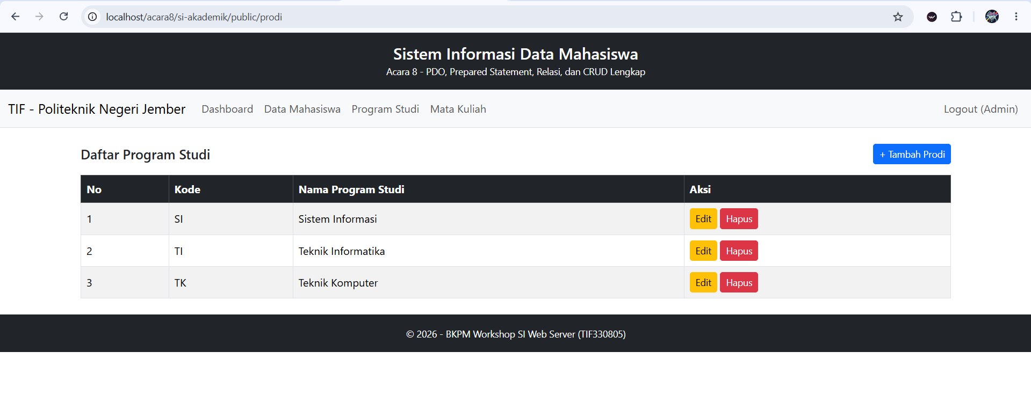
- /prodi/create
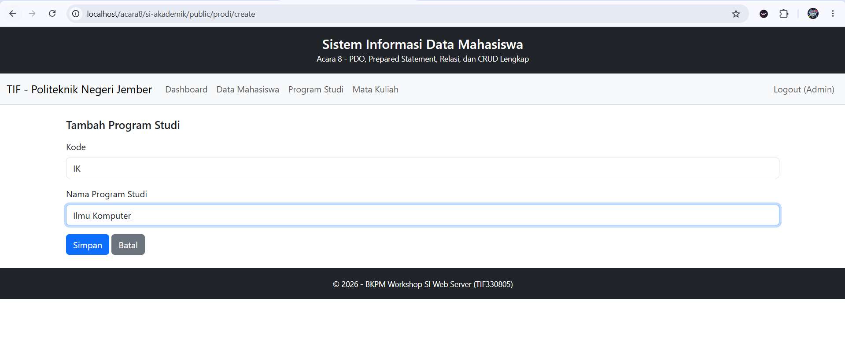
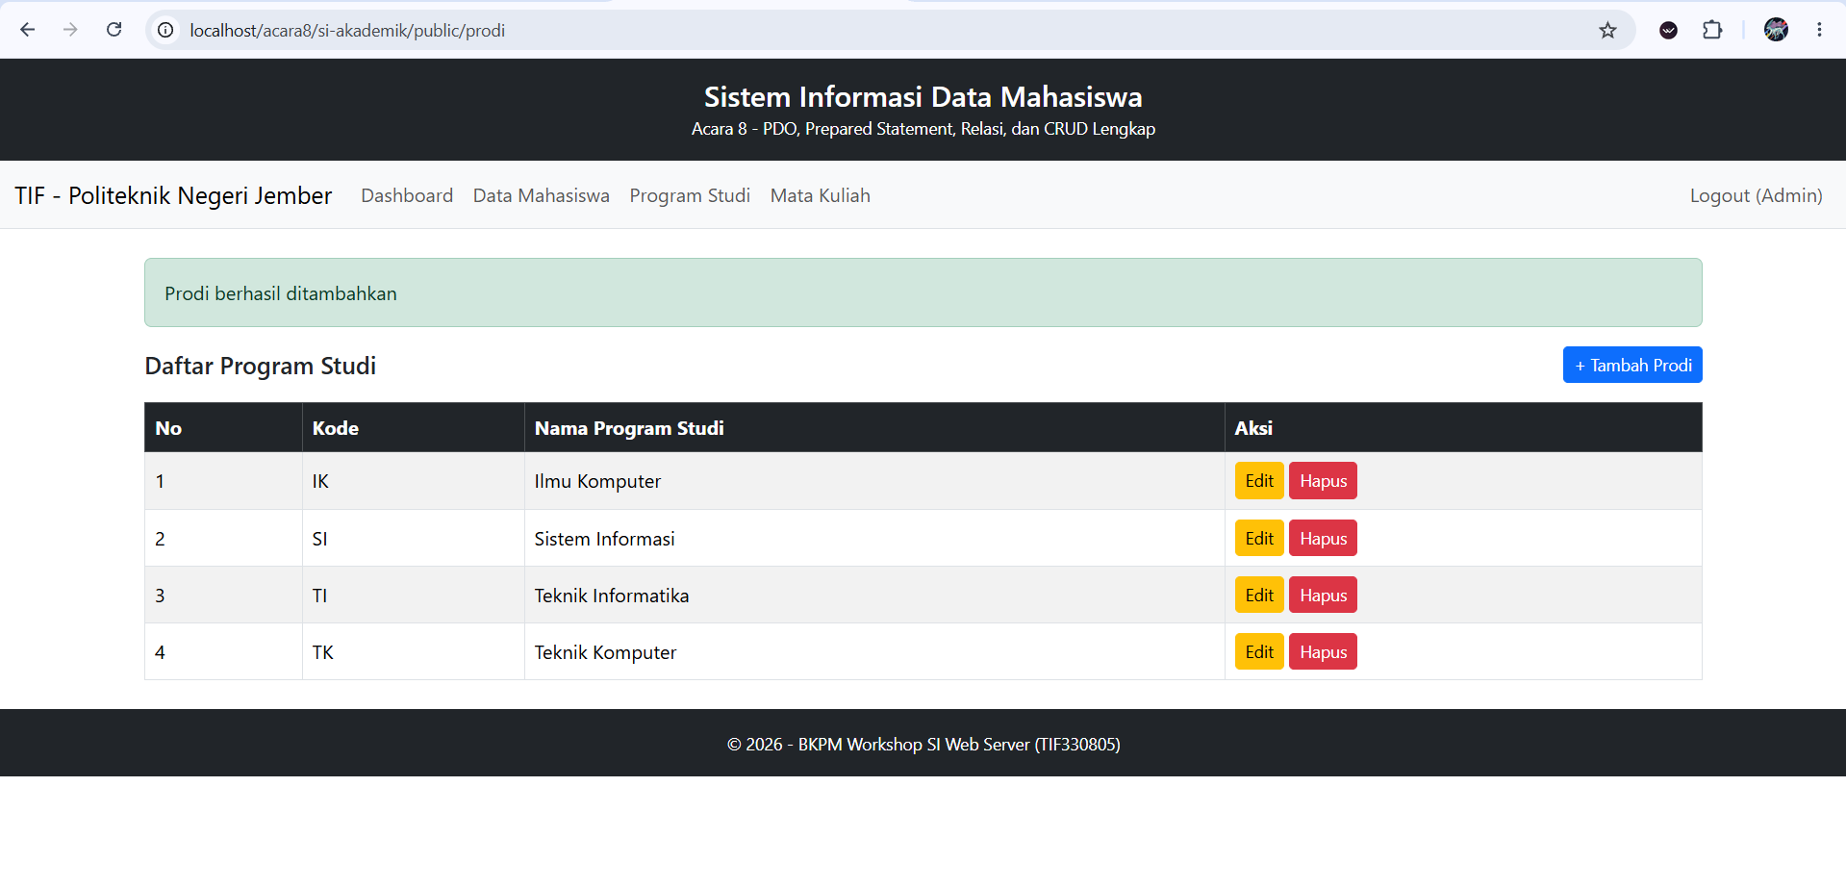
- /prodi/1/edit
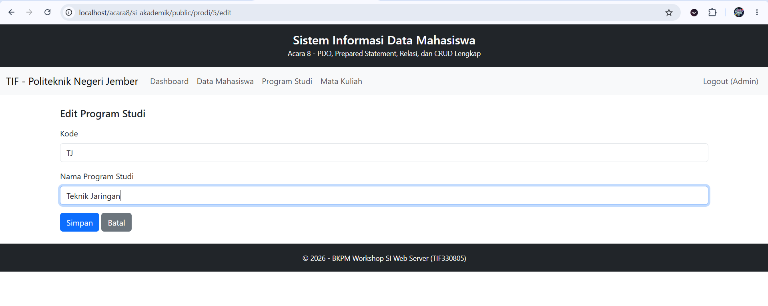
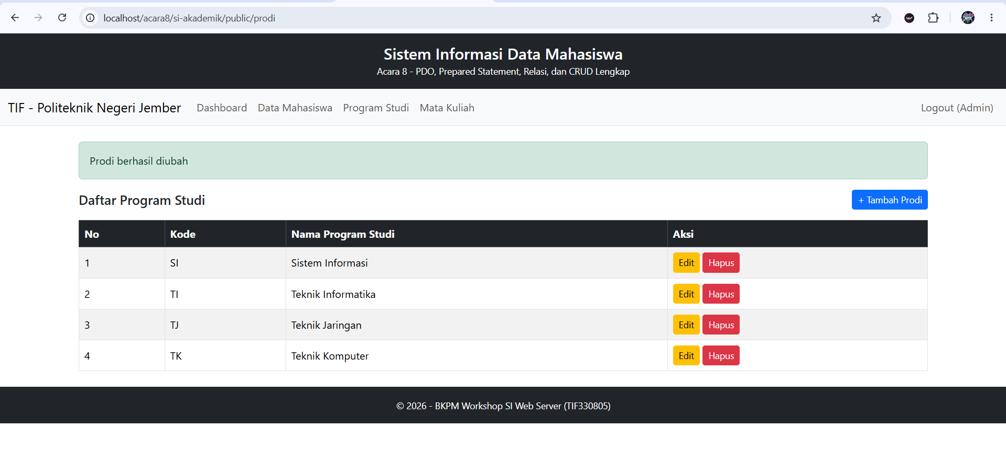

- Hapus /prodi
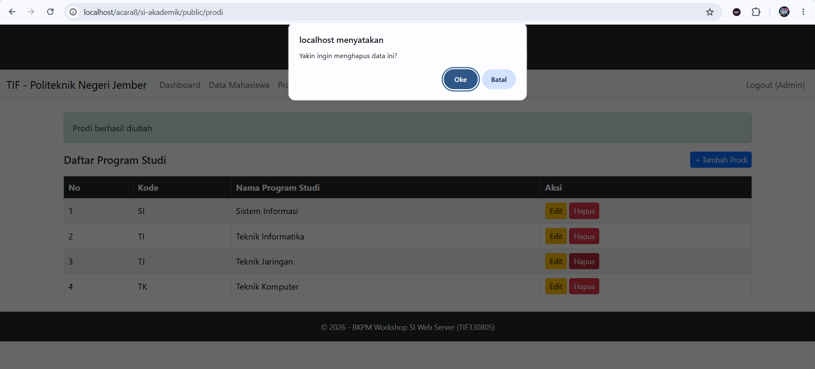
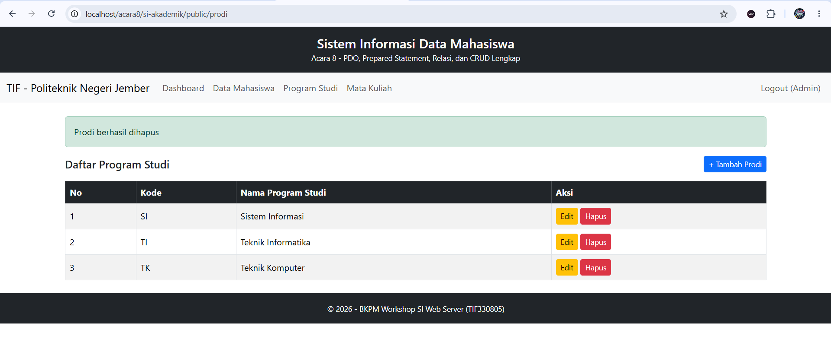
- /matakuliah
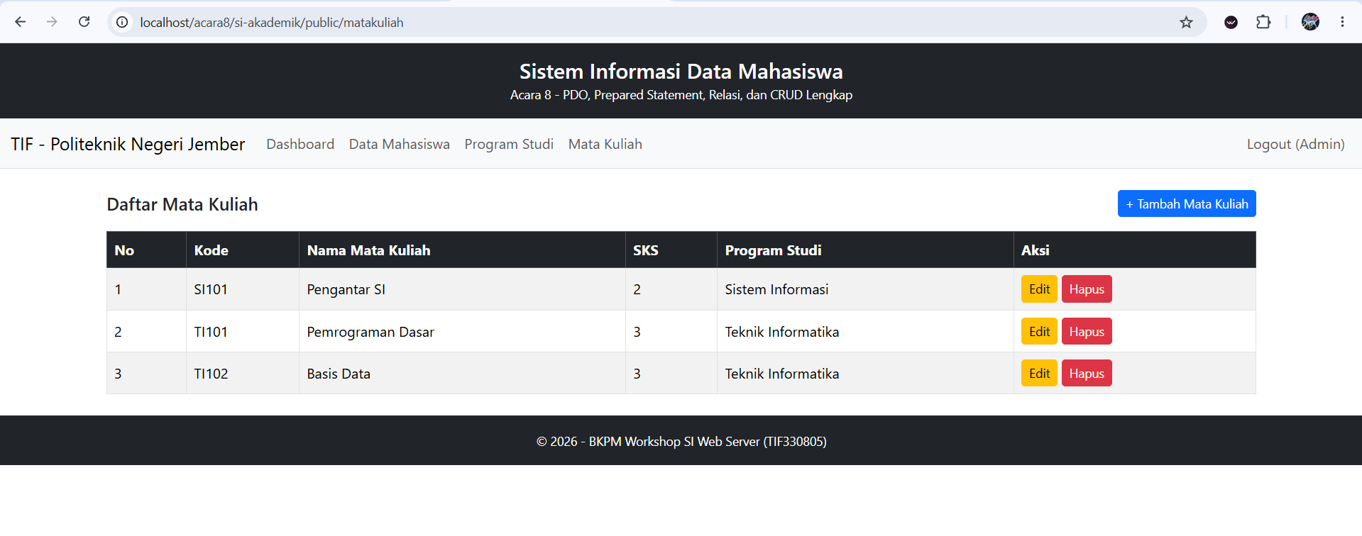

- /matakuliah/create
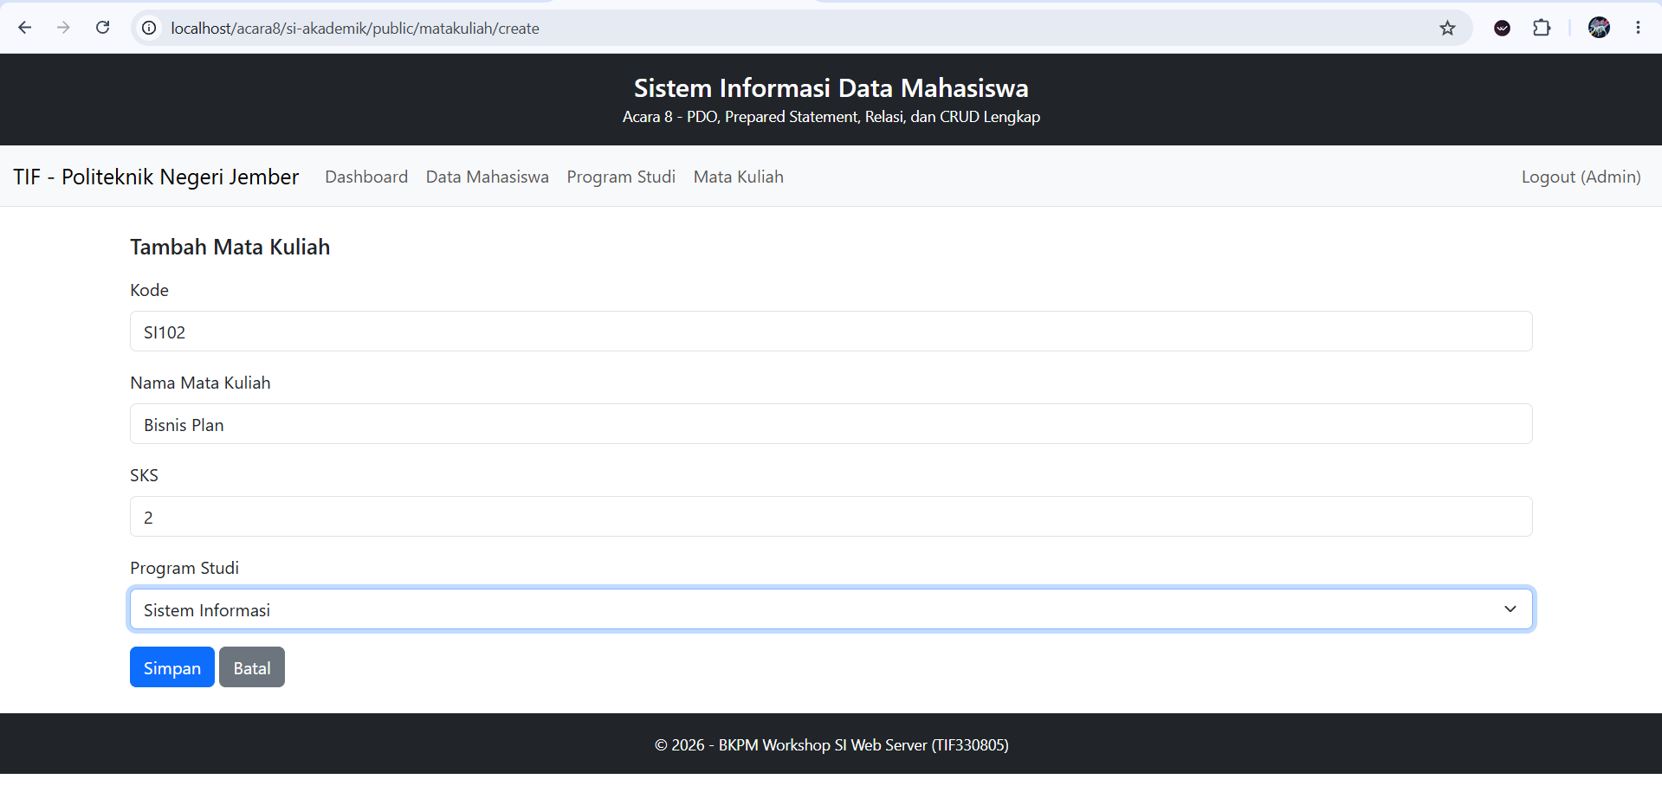
- /matakuliah/1/edit
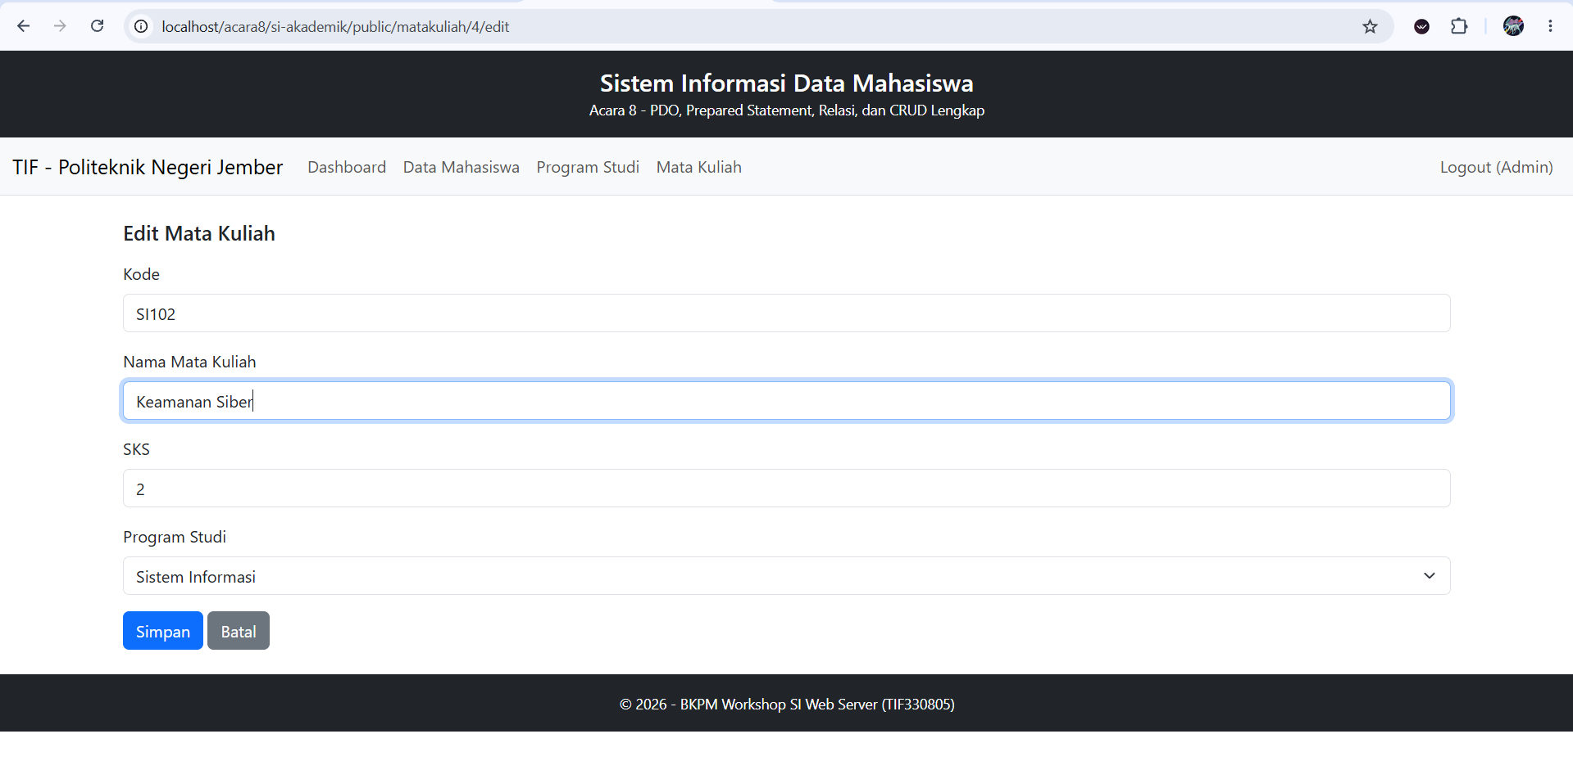
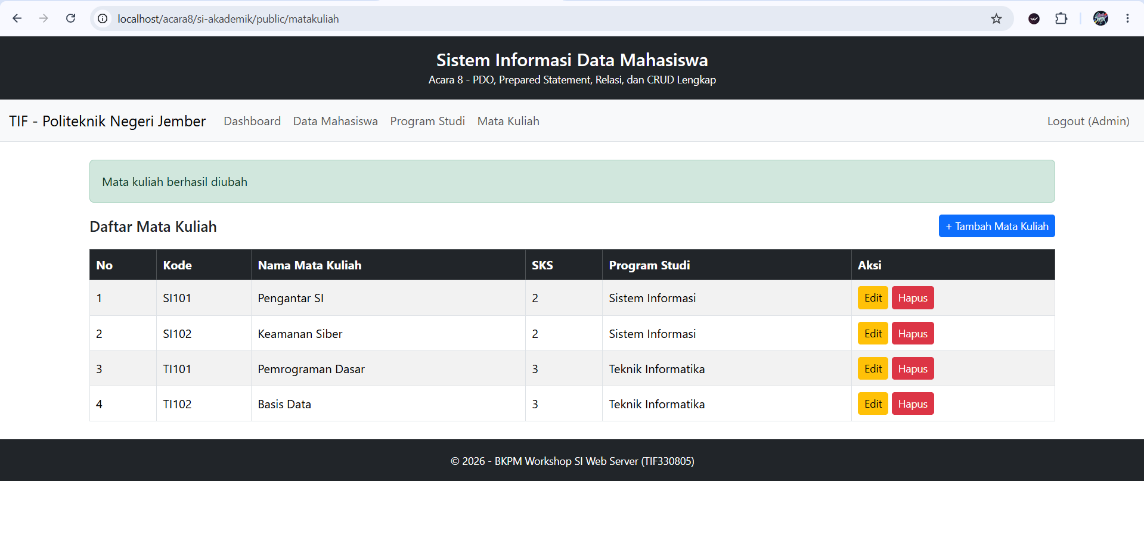
- Hapus /matakuliah
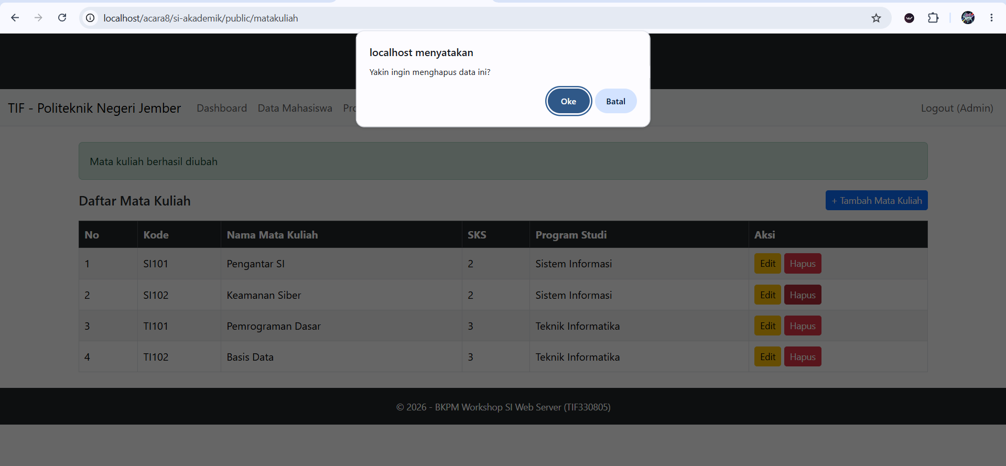
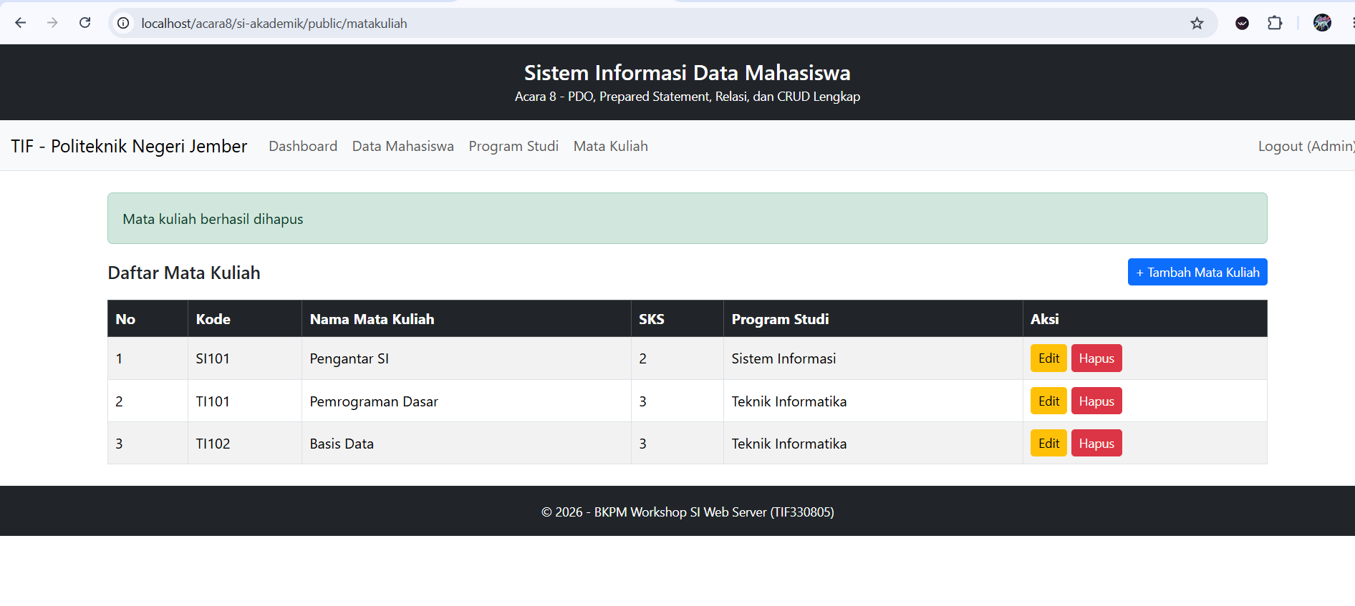
- Pastikan JOIN digunakan saat menampilkan daftar mahasiswa (tampilkan nama prodi).
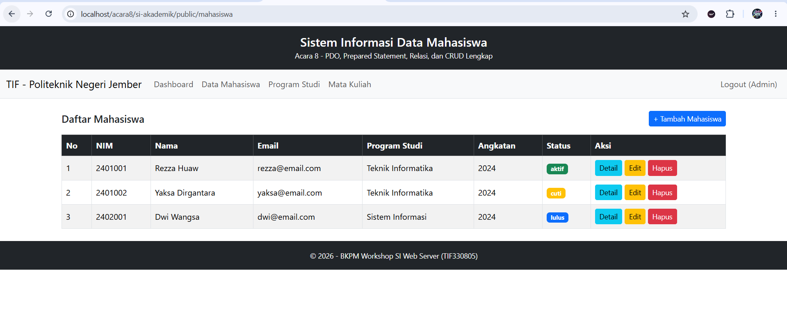
- Tambahkan konfirmasi JavaScript sebelum hapus.
<form action="/acara8/si-akademik/public/mahasiswa/<?= $mhs['id'] ?>/delete" method="POST" class="d-inline"
onsubmit="return confirm('Yakin ingin menghapus data ini?')">
<button type="submit" class="btn btn-sm btn-danger">Hapus</button>
</form>

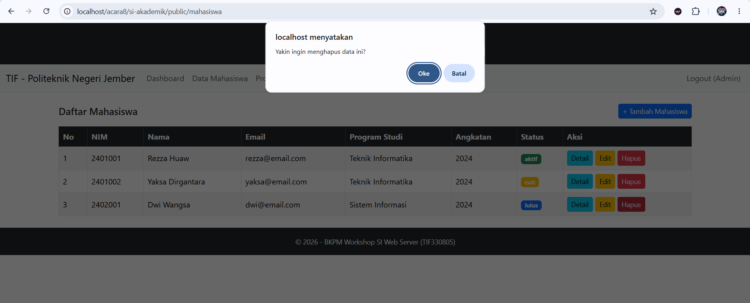
- Tugas Mandiri
Tambahkan fitur pencarian (search) pada halaman index mahasiswa berdasarkan nama atau NIM, menggunakan LIKE dengan prepared statement.
- Menambahkan code app/Models/MahasiswaModel.php
public function search(string $keyword): array
{
$sql = "SELECT m.*, p.nama AS prodi
FROM mahasiswa m
JOIN prodi p ON m.prodi_id = p.id
WHERE m.nama LIKE :kw_nama OR m.nim LIKE :kw_nim
ORDER BY m.nim";

$stmt = $this->db->prepare($sql);
// Nama parameter dibuat berbeda karena EMULATE_PREPARES = false
$stmt->execute([
'kw_nama' => "%{$keyword}%",
'kw_nim' => "%{$keyword}%",
]);

return $stmt->fetchAll();
}

- Menambahkan code app/Controllers/MahasiswaController.php
public function index(): void
{
$model = new MahasiswaModel();

// ===== TUGAS MANDIRI =====
$keyword = trim($_GET['q'] ?? '');
$daftarMahasiswa = $keyword !== '' ? $model->search($keyword) : $model->all();
// ===== AKHIR TUGAS MANDIRI =====

$content = __DIR__ . '/../Views/mahasiswa/index.php';
require __DIR__ . '/../Views/layouts/main.php';
}
- Menambahkan code app/Views/mahasiswa/list.php
<form method="GET" action="/acara8/si-akademik/public/mahasiswa" class="row g-2 mb-3">
<div class="col-md-5">
<input type="text" name="q" class="form-control" placeholder="Cari nama atau NIM..."
value="<?= htmlspecialchars($keyword ?? '') ?>">
</div>
<div class="col-auto">
<button type="submit" class="btn btn-outline-primary">Cari</button>
<a href="/acara8/si-akademik/public/mahasiswa" class="btn btn-outline-secondary">Reset</a>
</div>
</form>
- Output
